**Online Payment Fraud Detection**

Computer Science Capstone

by

Kyle Hogue

Western Governors University

**Table of Contents**

**Letter of Transmittal** ………………………………………………………………................4 **Project Proposal** ……......................................................................….......…...................……5

Problem Summary……………………………………………………………………...5

Proposed Solution………………………………………………………………………5

Project Benefits…………………………………………………………………………5

Data Description………………………………………………………………………..6

Project Objectives and Hypothesis……………………………………………………..6

Methodology……………………………………………………………………………6

Funding Requirements………………………………………………………………….6

Stakeholder Impact……………………………………………………………………..7

Data Precautions………………………………………………………………………..7

Expertise and Experience……………………………………………………………….7

**Executive Summary** …………………………………………………………………………..8

Problem Summary………………………………………………………………………8

Customer Analysis………………………………………………………………………8

Existing System Analysis……………………………………………………………….8

Data……………………………………………………………………………………...9

Project Methodology…………………………………………………………………….9

Project Outcomes……………………………………………………………………….10

Implementation Plan…………………………………………………………...……….11

Evaluation Plan………………………………………………………………….……...11

Resources and Cost……………………………………………………………………..12

Timeline and Milestones……………………………………………………………….12

**Project Application…………………………………………………………………………**...13

Link to Application…………………………………………………………………….13

**Post-Implementation Report** ………………………………………………………………...14

Project Purpose………………………………………………………………………....14

Datasets…………………………………………………………………………………14

Data Product Code……………………………………………………………………...16

Hypothesis Verification………………………………………………………………...16

Effective Visualization and Reporting………………………………………………….17

Accuracy Analysis………………………………………………………………………18

Project Testing…………………………………………………………………………..19

Project Files……………………………………………………………………………..19

User Guide………………………………………………………………………………19

Learning Experience…………………………………………………………………….23

**Works Cited……………………………………………………………………………………**.24

**Letter of Transmittal:**

**Mr. John Smith**

Chief Executive Officer

Bank of Utopia Inc.

777 N. Paradise Avenue

Amaurot, UT 77777

May 26, 2022

Dear John Smith,

During our recent meeting, a problem was raised in regards to fraudulent transactions and our companies current response. After a thorough review and cooperation with our Cybersecurity, IT, and Accounting departments, it appears that a significant subset of fraudulent transactions are not being reported at all under our current security practices.

I believe these instances of fraud need to be addressed quickly and precisely before our client base begins to lose faith in our ability to safely manage their monetary assets. To that end, I propose the development of a machine-learning algorithm to quickly and accurately identify fraudulent transactions. This application would be available to review transactions individually and validate them with a high degree of accuracy.

The application will be a console based algorithm capable of validating individual transactions and requiring no personal or identifiable data from our clients themselves, maintaining current security standards. Upon completion, the application could be tested alongside our current methods for a period of a three months to verify efficacy. Afterward the application could be easily entered into our data processing pipeline to have every transaction checked for potential fraud.

The estimated budget for this project is $11,600. This budget includes all necessary hardware, software, and human resources. With my 3 years of experience tailoring machine-learning models to various business needs, this project provides very little risk and potentially massive rewards.

I look forwards to discussing the our next steps towards solidifying the future of Bank of Utopia. Thank you for your consideration.

Sincerely Yours,

Kyle Hogue

Senior Engineer, Bank of Utopia Inc.

**Project Proposal**

**Project Summary**

Fraudulent online transactions result in a large profit loss each fiscal year. Our current detection system completely misses a significant amount of fraudulent transactions resulting in millions of dollars in theft and an increasing distrust from our client base.

Online transaction fraud has seen a substantial increase in recent years. Bank fraud has increased by over 50% and Credit card fraud has increased almost 45% all in a single year. Identity theft also saw a substantial increase ranging from 113% to over 1000% depending on type of theft. All this indicates that this is an industry-wide problem and efforts should be made to address it in a consistent and secure way.(Daly, 2021)

Despite numerous improvements to data security and verification measures, often times sensitive data is lost physically or from third parties. In such situations our organizational response is relegated to identifying and stopping fraudulent transactions as they occur or shortly thereafter. Implementing a machine learning model will allow our systems to identify fraudulent transactions more quickly and to implement protective measures immediately to prevent further fraud and protect our customers.

The goal of this project is to develop a machine learning model to quickly predict whether a sample transaction is fraudulent using non-identifiable client data to an accuracy of greater than 99%.

**Proposed Solution**

For this project, we will implement a stand-alone machine learning model trained using a Random Forest Classifier. The model will be trained with a large data set of transactions where each fraudulent transactions is one that slipped past our current security methods. This model will be judged primarily on accuracy using the in-built metric from the ‘sklearn’ python library. The model will then be made available via a simple console-based interface. This will allow any employee to identify fraud with increased accuracy and will help reduce loss and increase client confidence.

**Project Benefits**

Machine Learning provides the benefits of removing human bias from fraud detection. Even assuming proper motivations, traditional coding methodologies can leave large gaps in fraud detection systems. Machine Learning can also greatly increase the speed of detection by not requiring manual review of transactions. Further, more data can only improve both the speed and accuracy of detection measures, improving more over time.

**Data Description**

The data that will be used for the machine learning model is a collection of online transactions stored in CSV format. It contains encoded account numbers to protect client privacy, but otherwise nothing identifiable besides very specific transactions amounts. The data set is composed of millions of transactions, however only a subset will be used. This will also allow us to train the model better as we can use large number of transactions.

While the data set contains enough information to train our model, the data in contains in relatively sparse compared to what could be provided. The ‘step’ column in particular references the hour in which a transaction was made. Limiting our model to an hour is a definite drawback given thousands of transactions can occur every minute.

This data set is available online via Kaggle.com. (Roy, 2022)

**Project Objectives and Hypothesis**

This projects objective is to reduce the total number of fraudulent transactions missed by current security practices. This project aims to meet this objective by creating a machine learning model to take transaction data and output a prediction of whether the transaction is fraud or not.

This project’s acting hypothesis is: If a machine learning model is trained with transaction data, then the resulting model will be more than 99% accurate according to the in-built accuracy metric.

**Methodology**

Development will follow the SEMMA methodology. SEMMA stands for Sample, Explore, Modify, Model, Assess. The data set used is quite large so a ‘Sample’ will be taken to be verified, sorted, and validated. The the sample is ‘Explored’ to better understand how each variable contributes to the whole. Data visualizations are extremely useful in this stage. The next stage is ‘Modification’ of the data subset. During the exploration phase, some data may be in the wrong form or not useful to the intended goal. The ‘Modify’ Phase is to clean the data until it can be used. Finally, the data is used to ‘Model’ a solution to the proposed problem. This model is the ‘Assessed’ to see if it has achieved its stated goal. If not, the process repeats until the stated goal is met.

**Funding Requirements**

The project’s funding requirements are entirely based around the product development and data wrangling to achieve the goal accuracy. The current provided business hardware is sufficient for this task and all software components being open-source funding is reduced to the number of hours required to hit the stated target of 99% accuracy. The estimated budget provides both a minimum required man-hours for project completion as well as a solid end-date. After the end-date, if the goal has not been reached, management can reassess to see if an extension is worth the investment

* Project Minimum: $5,600.00
* Project Maximum: $11,600.00

**Stakeholder Impact**

This project has massive benefits for both Bank of Utopia and its clients. The primary benefit applies to the clients first but the results spill over into business benefits as well. First and foremost this project will help identify fraudulent transactions that our current system has missed as well as setting the stage for further security advancements. Our clients get the increased security of their monetary assets with the side benefit of increased confidence in Bank of Utopia’s effort on their behalf. This will translate into good press for the company and potentially set a new security standard that has the potential to lure clients away from our competitors, thus increasing our client base.

**Data Precautions**

At this stage, the data set in use contains no sensitive nor any identifiable client information. Should the project prove a success further security measures will need to be enacted to ensure data integrity. These should include, but not be limited to, restricted access, logging, audits, encryption, and perhaps even client consent forms.

**Expertise and Experience**

The developer tasked with this project has 10+ years of development experience. Five years have been spent developing software solutions to business problems with the last three focused exclusively on data management and machine learning. Recent focus under Bank of Utopia direction has been the development of data and security tools to streamline worker performance.

**Executive Summary**

**Problem Summary**

Due to our recent increase in volume of transactions our previous fraud detection measures have fallen behind in terms of both time to detection and accuracy of identification. This project will produce an application implementing a Random Forest Classifier to train a machine learning model to predict whether a transactions is fraud or not with a greater than 99% accuracy. This will allow each transaction to either be flagged for review or the associated accounts to be frozen at the discretion of our security department.

**Customer Analysis**

Our client’s and their assets are the literal life-blood of Bank of Utopia. Currently our security measures allow a portion of fraudulent transactions through with no response. Until of course our clients report the issue to us. This lack of knowledge and delayed response hurts our client’s confidence in our ability to protect their assets. This project model, trained for accuracy above all else, will bring potential fraudulent transactions to our notice almost as soon as it reaches our systems. At first, the application will be used alongside our current security measures for performance tuning and adjustment. The basic use of the application will require no additional skill beyond simple data entry. Once the accuracy has been verified to function at an appropriate level, the model can be implemented directly into our online transaction pipeline. Such an addition would insure that every transactions can be checked as soon as it enters our systems.

**Existing System Analysis**

Our current system of fraud identification code comes in the form of simple hard-coded rules concerning each transaction. At current time, transactions are flagged through software as fraud if they trigger one of the following use-cases:

* Transaction amount is 20% or more above the clients average.
* Transaction’s location is outside the local area.
* Multiple transactions in a short amount of time.

While such considerations do indicate something out of the norm, fraud is not a surety. Further, the gaps through which fraudulent transactions can fall are massive.

The proposed project will be able to review each of these cases as well as any other and predict fraud with an accuracy of greater than 99%. Upon completion, the machine learning model will be able to classify a transaction upon the manual entry of a transactions basic details. The clients average purchase price or location will not even be needed, thus further protecting client confidentiality.

**Data**

The data to be used for this project is a collection of online transactions in CSV format. The data contains the following columns, listed below with their corresponding data types.

* Step: int
* type:string
* amount:float
* nameOrig:string
* oldbalanceOrg:float
* newbalanceOrig:float
* nameDest:string
* oldbalanceDest:float
* newbalanceDest:float
* isFraud:int
* isflaggedFraud:int

The final column is essentially useless as none of these transactions are flagged fraud, even though a portion are marked as such under the ‘isFraud’ column. The ‘type’ column will require the use of sklearn.LabelEncoder() for conversion to fit the training model. Potentially a similar process will be needed for the ‘name****’ columns. The ‘step’ column will likely be dropped as hour long time increments are a bit too long to be useful. Thankfully the particular data set contains no ‘null’ values.

It should be noted that the data set is not balanced. There was some consideration on whether to correct the imbalances but ultimately it was decided against. The data set is significantly large enough that such considerations shouldn’t adversely affect the outcome. This decision will be readdressed if the target accuracy goal cannot be met.

**Project Methodology**

Development will follow the SEMMA methodology.

* **Sample:** The data set for this project comes from a previously compile collection of transactions downloaded from Kaggle.com in CSV format. (Roy, 2022) A reasonably large selection of the chosen data set is selected. This selection is further broken down into training and testing selections for the purposes of model training. The training/testing will follow a 70%/30% split.
* **Explore:** The data sample will be reviewed using a variety of python libraries. ‘Pyplot’ from ‘matplotlib’ and ‘seaborn’ will be used for the creation of graphs and data visualizations to assist in understanding the data set. Further, ‘sklearn.metrics’ will be used to give useful information that doesn’t lend itself to graphical representation.
* **Modify:** The sample will be checked for ‘null’ values and they will be corrected as needed. During this phase, the classifier values we are targeting will be assigned to a separate value (Y) and then dropped from the original data frame. The Random Forest Classifier also requires inputs to be numerical, so non-numeric values in the data set will be encoded using ‘LabelEncoder()’ from ‘sklearn’.
* **Model:** During the phase, I will be using the Random Forest technique to train the predictive model. If target has not been achieved, continued training is also an option using more transactions from the set.
* **Assess:** The success of this project is listed as a predictive accuracy of greater than 99%. Should the model fail to meet target, additional data exploration, data modification, and modeling will be necessary.

**Project Outcomes**

The deliverables outlined below consist of both the technical products and all necessary documentation.

* **Functional and Accurate Predictive Model:** A machine learning model trained with a Random Forest Classifier for an emphasis on accuracy in the identification of fraudulent online transactions.
* **User Interface:** A simple function to allow the input of the details of a transaction and return the model’s prediction. The user will be prompted to enter each of the six necessary data points, each with a basic description.
* **Complete Data Set:** The complete data set will be included. This will be provided alongside the necessary code to re-create the training and testing subsets in order to allow for third-party verification of the predictive model.
* **User Guide:** A text file will be provided that will give detailed instructions for the installation and use of the predictive model.

**Implementation Plan**

The steps below describing our plan to develop, implement, and deploy the predictive model for basic use will follow a modified version of the previously described SEMMA methodology. Namely, the ‘Explore’ and ‘Modify’ steps are done simultaneously to better represent practical workflows.

1. **Phase 1:** Applicable data set is collected from the repository. Data set is further reduced into a manageable size. (Data is now ready for Phase 2.)
2. **Phase 2:** Data is analyzed and explored for flaws, correlations, ‘null’ values, etc. Corrections are made as needed. Values are adjusted to be accepted by the training methods. Data set is split into the training and the testing subsets. Values deemed extraneous are dropped from the training data set. (Data is now ready for Phase 3.)
3. **Phase 3:** Predictive model is trained using the training subset of data. The model is then tested against the testing subset of data. Various performance metrics are collected about the trained model. (Model is now ready for Phase 4.)
4. **Phase 4:** The model and associated metrics are assessed to judge their performance against the stated goals of the project. (If goals are reached, proceed to Phase 5, else return to Phase 2.)

(**NOTE:** At this stage, if goals have not been reached, the project resets to Phase 2. Information gained and processes learned are incorporated and development continues until the stated goal is reached.)

1. **Phase 5:** A user interface is developed to allow access to the predictive model.

(Completion of Phase 5 signals the project is complete and ready to be deployed.)

**Evaluation Plan**

The evaluation of the model will primarily use the built-in metric from the ‘sklearn’ library ‘accuracy_score()’. This function returns the overall accuracy of a predictive model and the project will be deemed completed once a value of 0.99*** (or 99%) has been achieved. During the development phases of the project, further metrics of recall, precision, and the combined metric of the model’s F1 score will be taken into account.

**Resources and Costs**

|  |  |  |
| --- | --- | --- |
| **Resource** | **Description** | **Cost** |
| Computer Hardware | * OS: Windows 10 * 16 GB of RAM * x64-based processor   (Employer provided computer is acceptable.) | $0 |
| Software | * Visual Studio Code   + Jupyter Extensions   + Python Libraries     - pandas, sklearn, matplotlib, seaborn | $0 |
| Data Set | *Online Payments Fraud Detection Data Set* from Kaggle.com (Roy, 2022) | $0 |
| Machine Learning Engineer | Professional developer capable of delivering a business ready model in the proposed timeline. | $100/hr  @  56hrs-116hrs |
|  | **TOTAL COST**  **(min-max)** | **$5,600.00 – $11600.00** |

**Timeline and Milestones**

|  |  |  |  |  |  |
| --- | --- | --- | --- | --- | --- |
| **Task** | **Dependency** | **Activity** | **Start Date** | **End Date** | **Hours** |
| 1 | N/A | Project Approval | 5/21/22 | 5/21/22 | ? |
| 2 | Task 1 | Data Selection and Sampling | 5/22/22 | 5/23/22 | 8 |
| 3 | Tasks 1, 2 | Data Exploration | 5/23/22 | 5/25/22 | 16 |
| 4 | Tasks 1, 2, 3 | Data Pre-Processing | 5/26/22 | 5/28/22 | 16 |
| 5 | Tasks 1, 2, 3, 4 | Machine Learning Modeling | 5/29/22 | 5/30/22 | 8 |
| 6 | Tasks 1, 2, 3, 4, 5 | Model Assessment | 5/31/22 | 5/31/22 | 4 |
| ? | Tasks 1, 2  →  Tasks 5 | (Tasks 3-6 Repeat until Goal Achieved) | 6/1/22 | ? | ? |
| 7 | Task 6 | Assessment Verification with New Data Set | 6/1/22 | 6/1/22 | 4 |
|  |  | **TOTAL** | 5/21/22 | 6/15/22  (Final End) | 56 – 116hrs  (min-max) |

**Project Application**

**Application Link:**

<https://colab.research.google.com/drive/1tC4_cyMo1omTgXTsqmebWv3Gz6r4BZUZ?usp=sharing>

**Additional Files:**

**‘transactions.csv’ -**This file will be submitted separately. It is a small subset of data used for the predictive model’s training and testing purposes. This will need to be uploaded to the Google Colab session for full functionality.

(**NOTE:** See User Guide for Complete Instructions on Use.)

**Post-Implementation Report**

**Project Purpose**

The Bank of Utopia had seen an increase in fraudulent transactions that had slipped past the current security practices. This project was implemented to produce a machine learning model to predict whether a given transaction would be considered fraud. The implementation of this model is also intended to safeguard the bank’s and client’s assets while simultaneously increasing client confidence in the Bank itself.

This model has shown an accuracy rating of 99.92% given the most recent test set. This accuracy rating has been achieved with only a small subset of training data, leaving room for further improvements. In the applications current form it is only usable to check individual transactions as an assistant to our Security department.

**Datasets**

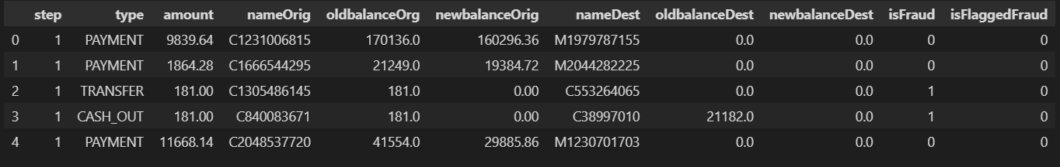The data set used was in the form a clean CSV file. The file itself contained the data of more than 6 million transactions. Sample below:

This data contained non-float values that the training function would not accept as well as quite a few columns that provided little useful information. The data changes made are listed below:

* **‘step’ and ‘isFlaggedFraud’ columns were dropped -** ‘step’ is hourly timestamp data and an hour is too long to be useful. All values in ‘isFlaggedFraud’ are 0, and thus useless.
* **‘type’ was converted to a numerical value –**  I used ‘LabelEncoder()’ from ‘sklearn’.
* **‘nameOrig’ and ‘nameDest’ were dropped –** This took some experimenting. I originally encoded them similar to the ‘type’ column but after running the training with a variety of column selections, their inclusion resulted in lower scores.

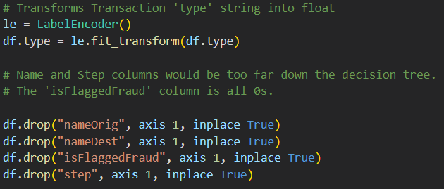

The resulting data set is pictured below before being split into X (independent) and y (dependent) variables.

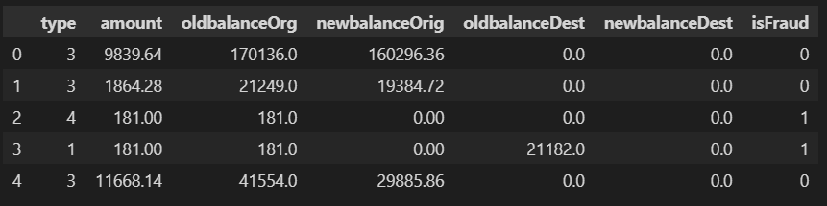

This data set is the split into the independent and dependent variables, and seperated into training and testing sets. Pictured below:

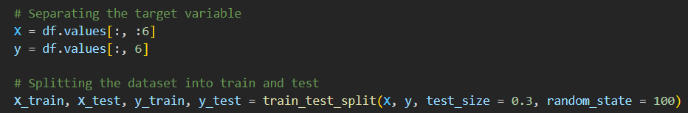

**Data Product Code**

The code creates a model using a Random Forest Classifier, then trains it using the separated variables. The following Testing section uses the separated test variables to verify the model’s functionality. The various metrics displayed provide additional data to assess the model.

(**Note:** The Jupyter Notebook file with all code along with the needed CSV file will be included in the submission.)

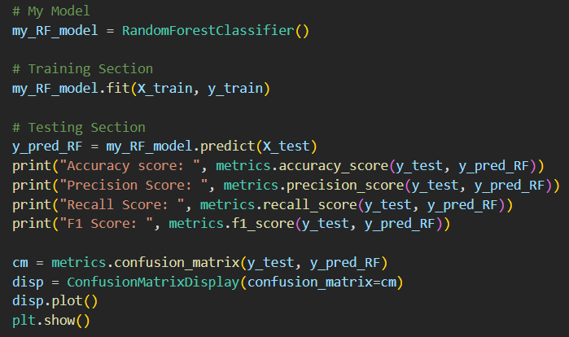

**Hypothesis Verification**

The initial hypothesis was that a machine learning model could prove to be greater than 99% accurate. The pictured results below show a 99.92% accuracy rating, meeting and exceeding the hypothesis. The other included scores were used for further refinement of the data set and are out-of-scope for this project or hypothesis. They were left in for context to show that high accuracy comes at costs else-where. (For each of the following scores, closer to 1.0 is better.)

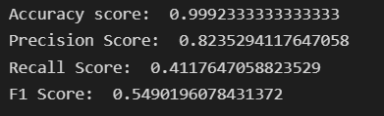

**Effective Visualization and Reporting**

The first data visualizations used was a basic pyplot histogram of every column. One the original 11-column data set, it was a massive mess that told me little. However I began to use seaborn graphs and to play with the variables until something began to make sense.

The first graph showed clearly that all transactions marked as fraud were of only two ‘type’s. I quickly used a pie graph to figure out that those transactions themselves were only a percentage of the total.

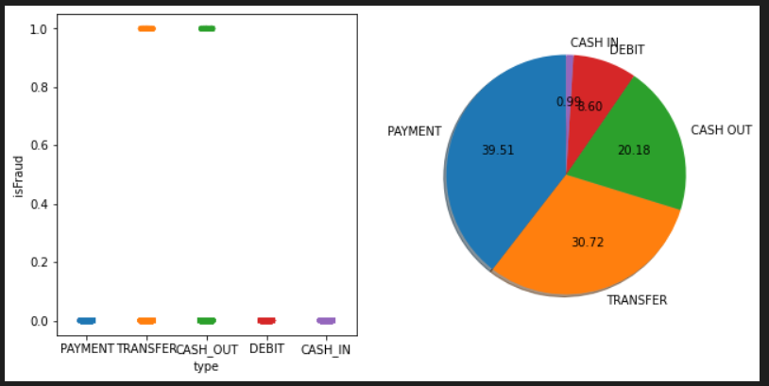

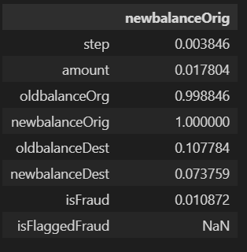A correlation focused on a specific column gave further insight into fraud patterns I could take into account in the building of my model.

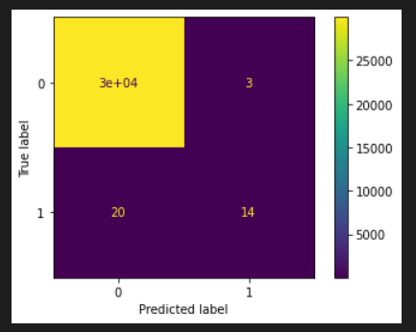

Lastly, a visual representation of a confusionmatrix helped me to understand how accurate my model was and also where it would make mistakes.

**Accuracy Analysis**

Below I have pictured the combined test results I achieved from my model. The primary gauge of the model’s accuracy is based on the top result, the ‘Accuracy score’. This is the result of an built-in metric in the ‘sklearn’ python library. It is a simple percentage based calculation of the number of predictions made versus their true values.

While this was the overarching goal of the project, the other metrics are far more interesting.

The Precision score is calculated using the number of TP (true positives) and number of FP (false positives). TP/(TP+FP) gives a relatively high value at 0.82. The Recall score is calculated similar to Precision but instead of FP (false positives) it uses FN (false negatives). TP/(TP+FN) gives a terrible score of 0.41. The F1 Score is the harmonic mean of Precision and Recall, giving us a nice number to represent both. As you can see, the F1 score is quite low.

The Confusion Matrix shows all this clearly. While the overall accuracy is above 99.9% given the test set, there were three False Positive (FP) predictions, and 20 False Negative (FN) predictions. This means that 20 cases of fraud still would have slipped through our prediction model while 3 clients would have been bothered needlessly. (It should be noted that the test set was composed of 30,000 transactions.)

Further refinement could come from tuning the recall stat to be purposely higher than the precision stat while still keeping overall accuracy high. This would allow through fewer cases of actual fraud but bother clients more. Such actions could even provide positive publicity for being so active in their protection.

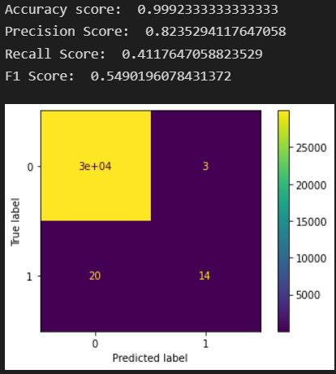

**Project Testing**

This project used the following testing methods to aid development and the project goals were met:

* **Unit Testing:** Each section of code was tested to verify that it worked before moving on to the next section.
* **Integration Testing:** The entire project was tested multiple time with different data subsets to verify accuracy and repeatable results.
* **User Acceptance Testing:** The project was sent with the provided ‘User Guide’ to a non-technical user to ensure clarity and functionality of the project as a whole.

**Project Files**

This application will be submitted as a zipped folder titled: “Capstone.zip”.

**Files:** “capstone.ipynb”

“transactions.csv”

**User Guide**

The project file have been submitted as mentioned above. The ‘.ipynb’ file can be opened into a Jupyter Notebook for review and the ‘.csv’ file will provide the needed data set. For ease of access I have provided step-by-step instructions for how to access this applications via Google Colab.

1. **Follow this Link:** <https://colab.research.google.com/drive/1tC4_cyMo1omTgXTsqmebWv3Gz6r4BZUZ?usp=sharing>
2. **Click on the Folder Icon:** Circled in yellow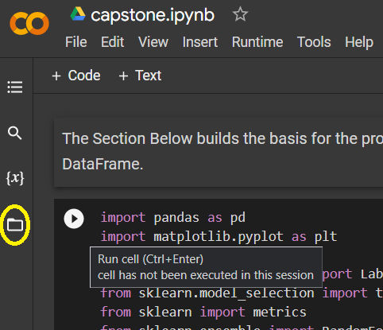 in the picture, click on the folder icon.
3. 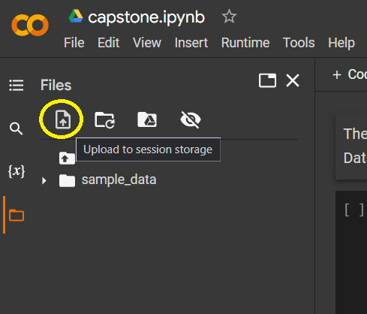**Click on the ‘Upload’ Icon:** In the tab that opens, click on the ‘Upload’ icon.This will open a file explorer for our system. Please find and select the provided “transactions.csv” file. Click ‘Open’ to begin upload.
4. 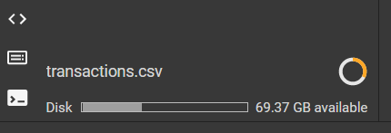**Wait for it to Upload:** At the bottom of that same tab the file name and progress ‘circle’ will appear. Once complete the file will also appear underneath the ‘sample_data’ folder seen above.
5. **The application is now ready to use:** 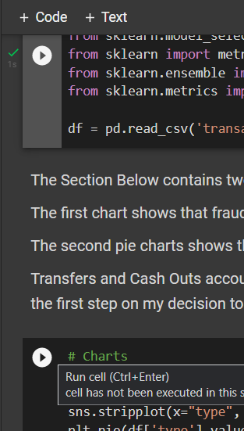In order, from top to bottom, press the ‘play’ button pictured to run the code cells. Each one depends on the one before it. At times, charts and graphs will appear, keep scrolling down to continue.

A green ‘check’ mark will appear once a code cell has been run successfully.

1. **User Input and Application Testing:** T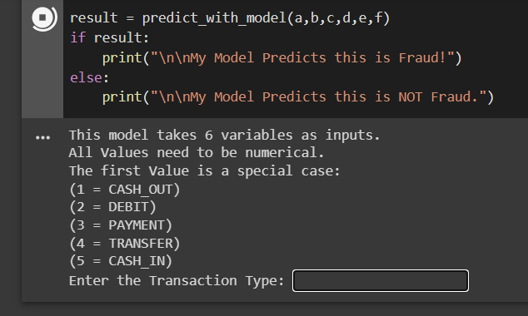he final cell will prompt the user for six separate inputs to test the predictive model. ***All inputs must be numerical!!!!***
2. A brief description of the data needed will be provided. Once entered a result will be displayed at the bottom of the screen. Along with the inputs you entered. (See below.)

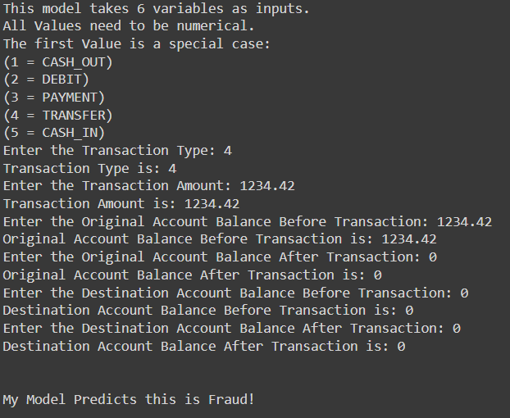

You can test more inputs by hitting the ‘Play’ button for that specific cell only.

**Learning Experience**

This Capstone was very enlightening. I had basically no previous experience with machine learning and had to start from scratch. My previous experience with python and its wonderful data libraries was soon put to good use even if Jupyter Notebooks was also new to me. Once I had wrapped my head around the concept of training a model and testing it, everything else just clicked. I must have played with every available machine learning algorithm ‘sklearn’ has and applied them to multiple Kaggle.com data sets just to see what it would do. Another huge factor that helped in the completion of this project is my experience in writing reports, both for school and in my professional life.

Previously my lack of experience lead me to believe that machine learning algorithms needed to be developed individually for each topic. Knowing now, how easily and broadly they can be applied has opened my eyes to a wide range of possibilities. I feel confident that when asked I could apply machine learning techniques to problems given to me by future employers. I also look forward into continuing to research different applications of machine learning and other subsets of Artificial Intelligence.

**Works Cited**

Roy, R. (2022, April 17). *Online payments fraud detection data set.* Kaggle. Retrieved May 20, 2022, from https://www.kaggle.com/datasets/rupakroy/online-payments-fraud-detection-dataset

Daly, L. (2021, October 27). *Identity theft and credit card fraud statistics for 2021: The ascent*. The Motley Fool. Retrieved May 18, 2022, from https://www.fool.com/the-ascent/research/identity-theft-credit-card-fraud-statistics/